CHARM-EU News

Contact information
CHARM-European University Alliance
Nicole Font, CHARM-EU Communication Manager
Email: nfontg@ub.edu; info@charm-eu.eu
CHARM-EU Days: How can European Universities initiative contribute to supporting the European Green Deal?
For immediate release: Friday, 30 October 2020
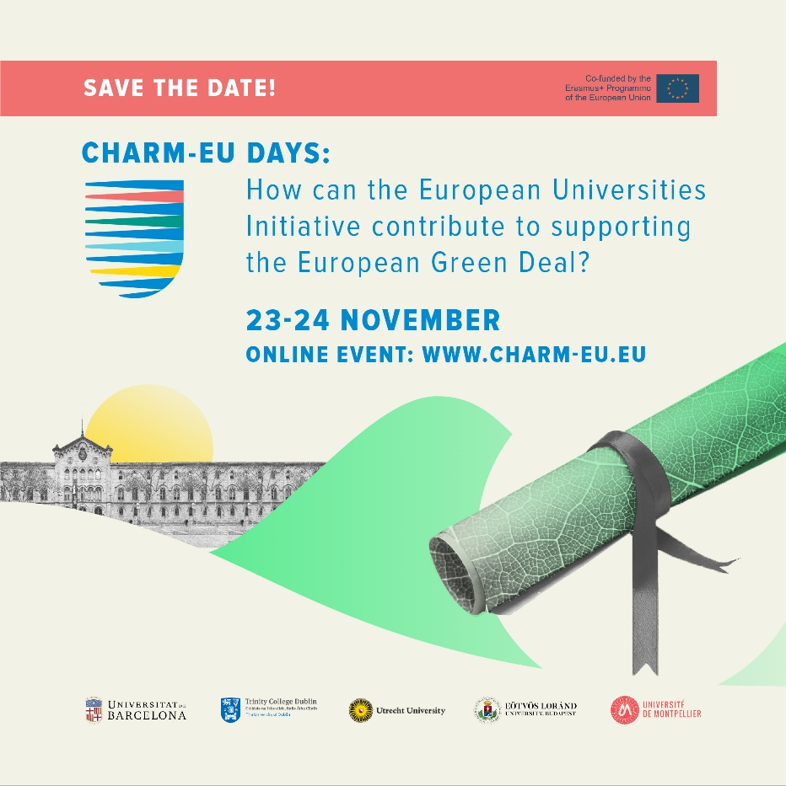
This first edition of CHARM-EU Days will explore the future of the European Higher Education landscape and its role in addressing complex and interlinked societal challenges, in particular on how to support the European Green Deal.

Climate change and environmental degradation are an existential threat to Europe and the world. In addition, the world is facing unexpected challenges caused by the COVID-19 scenario. To overcome these challenges, the European Union (EU) developed a new growth strategy: the European Green Deal for the EU and its citizens[1]. Whilst, all EU actions and policies will have to contribute to the European Green Deal objectives, the higher education sector - as one of the main contributors in educating those who will shape our society – must to play a key role in achieving these goals.

As an active supporter of the European Green Deal plan, CHARM-EU (Challenge-driven, Accessible, Research-based, Mobile European University) would like to invite you to participate in the CHARM-EU Days: “How can the European Universities initiative contribute to supporting the European Green Deal? next 23-24 November 2020. This first edition of CHARM-EU Days will explore the future of the European Higher Education landscape and its role in addressing complex and interlinked societal challenges, in particular on how to support the European Green Deal.

The CHARM-EU Days is a unique opportunity for participants to reflect and discuss the potential of European Universities in shaping the present and the future of our society by reinforcing its commitment with the EU’s Green Deal action plan.

Registration is FREE and will open soon. All webinar sessions will be live streaming and recorded and published on the CHARM-EU Website: www.charm-eu.eu

Follow us:
Twitter: @charm_eu
Facebook: @charmeu.initiative
Instagram: charm.eu
LinkedIn: https://www.linkedin.com/company/charm-eu
Website: www.charm-eu.eu
Subscribe to our newsletter here.

