**YOUR PRACTICAL INFORMATION PACK FOR THE HYBRID CONFERENCE**

**CHARM-EU INCLUSION CONFERENCE - CREATING AN #INCLUSIVEUNIVERSITY. ACCESS AND PARTICIPATION IN EUROPEAN HIGHER EDUCATION: CHALLENGES AND ENABLERS**

**16TH SEPTEMBER 2022 9:30-17:30 CEST**

# A WARM WELCOME

We are delighted and honoured that you accepted our invitation to attend and contribute to the CHARM-EU Inclusion Conference. Creating a welcoming, inclusive, and respectful conference experience that caters to the greatest extent of individuals needs a thorough design, delivery, and monitoring. We provide you with essential information to ensure a joyful conference atmosphere and experience for everyone!

We are glad to share that [CHARM-EU](https://www.charm-eu.eu/)  Alliance has been developing and innovating since 2019. Inclusion and diversity have been interweaving into CHARM-EU’s culture, design, delivery and monitoring of the work packages, its Master’s, and the core strategic and governance structures. It is our honour to work with the CHARM-EU community and beyond to support CHARM-EU’s reputation as an innovative, pioneering university model and a role model for social inclusion in diverse and complex societies.

We are grateful for the hybrid conference setting and thankful to the Faculty of Social Sciences at Eötvös Loránd University (ELTE) for hosting the conference to meet in person.

On behalf of the community of CHARM-EU and the Eötvös Loránd University, I wish everyone a fruitful conference. I hope we will keep the dialogue growing and create tangible steps for a more inclusive and diverse higher Education within the European Higher Education Area and beyond!

Yours sincerely, Agnes Sarolta Fazekas

CHARM-EU WP6 Work Package Leader on Inclusiveness

Budapest, 18 August 2022

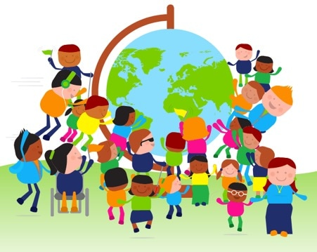

**PICTURE 1**: The picture displays people surrounding the globe

LIST OF CONTENT

A WARM WELCOME 1

CONFERENCE INFORMATION 3

1. Questions, queries - whom to contact 3

2. Conference Information and Social Links 3

3. Event hashtags 3

4. Internet Access 3

5. Roaming and Country Code for calling 3

6. Inclusiveness is one of CHARM EU’s Core Values 4

7. Conference Atmosphere & ways of collaboration 4

8. COVID-19 considerations 5

9. Conference Hybrid Format 5

10. Access and participation in the venue 5

11. Environmental awareness 5

12. Conference engagement and materials 6

13. Breaks between sessions - Time is an Access Need for All 6

14. Energisers & Buffer Times 6

15. Speech-to-text Service Provision 6

16. Catering and Dietary Requirements 6

17. Privacy Notice & GDPR Regulations & Consent to photos/videos 6

18. Off-Camera Locations 7

CONFERENCE VENUE INFORMATION 7

19. Address, Map, Facilities 7

20. Restrooms 7

21. Floor Map – 0. Level (Northern Building (Északi Tömb) 8

TRAVEL IN BUDAPEST 9

22. Travelling to and from the Petőfi Bridge by Tram 4 or 6 or buses 9

23. Travelling with public transport 10

24. Accessible transport 10

25. MOL BUBI Facilities 10

26. Travelling by taxi and facilities 11

Hungary and Budapest Information 11

27. Weather Information Budapest Hungary 11

28. Budapest Districts 12

29. Hungarian Currency: Hungarian Forint (HUF) 12

30. In case of emergencies, Emergency Care 12

ONLINE PARTICIPATION 13

31. Access and participation in the online environment 13

32. Access the online platform 13

33. Step by steps on how to join the online platform 13

34. Zoom Platform Icons 13

35. Keyboard shortcuts for Zoom 14

36. The best Zoom keyboard shortcuts for Windows 14

37. The best Zoom keyboard shortcuts for macOS 14

38. The best Zoom keyboard shortcuts for iPadOS 15

THANK YOU, EVALUATION & COMMENTS 15

39. A thank you to various Support Personnel and Volunteers 15

40. Conference Evaluation Form 15

41. Comments on-location & online 15

# CONFERENCE INFORMATION

## Questions, queries - whom to contact

In case of any questions, queries, or emergencies, please, contact **Agnes Sarolta Fazekas**, CHARM-EU WP6 Inclusiveness Leader, e-mail: [fazekas.agnes.sarolta@barczi.elte.hu](mailto:fazekas.agnes.sarolta@barczi.elte.hu).

Registered guests on location and online will receive further information via e-mail on how to directly reach Agnes Sarolta Fazekas in case of emergencies, questions, or queries.

## Conference Information and Social Links

About CHARM-EU: <https://www.charm-eu.eu/>

About CHARM-EU Inclusion Conference<https://www.charm-eu.eu/inclusion-conference-2022>

Twitter: <https://twitter.com/charm_eu>

Facebook: <https://www.facebook.com/charmeu.initiative/>

LinkedIn: <https://es.linkedin.com/company/charm-eu>

Instagram: <https://www.instagram.com/charm.eu/>

## Event hashtags

#access #inclusion #diversity #highered #CHARMEU #InclusiveUniversity

## Internet Access

WIFI Network Name: **ELTE CHARM-EU**

Password: **inclusion2022**

## Roaming and Country Code for calling

Roaming:

* <https://europa.eu/youreurope/citizens/consumers/internet-telecoms/mobile-roaming-costs/index_en.htm>

Hungary Country Code for calling: +36

## Inclusiveness is one of CHARM EU’s Core Values

One of CHARM-EU’s core values is [inclusiveness](https://www.charm-eu.eu/core-values). We strongly believe in the power of diversity to enrich the learning experience as well as academic debate and knowledge creation and production. We see it as our social responsibility to foster an open, welcoming, and safe environment grounded in inclusivity, compassion, and mutual respect, where individuals from all backgrounds, lived experiences, circumstances and access needs can collaboratively learn, work, and serve. We are committed to creating excellence in teaching and learning by providing the appropriate structures and services that remove barriers to success and support student and staff access and participation needs.

## Conference Atmosphere & ways of collaboration

How we interact with one another affects the integrity of the CHARM-EU’s academic and workplace environments. This section communicates CHARM-EU’s organisational culture and how our values and principles are implemented across our activities, community, and stakeholders. We work towards a climate of respect, accountability, honesty, and integrity in the community as described in one of our core values - [inclusiveness](https://www.charm-eu.eu/core-values).

Designing and facilitating safer spaces are essential. Remember, language is powerful. Everyone’s language, behaviour, and attitude can shape the environment.Encourage inclusive language among speakers, facilitators, contributors, and participants. How to do that? Do not make assumptions; better to gently ask a question than to make assumptions.

Badges with pronouns and inclusive language communication materials can help to raise awareness. During the registration, your answer on your pronoun and how to be referred to by the CHARM-EU Inclusion Conference organisation team & participants provided information to address each other in the most respectful, inclusive way possible throughout all phases of the conference and beyond.

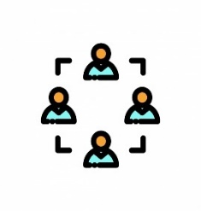

Active participation, co-building knowledge, sharing experiences

We work to create a climate of respect, accountability, honesty, and integrity in the community as described in one of our core values - [inclusiveness](https://www.charm-eu.eu/core-values).



Feel free to ask any concerns or questions



*“To Err is Human”[1]*. Please, approach the conference environment with flexibility, patience with the hybrid settings and access and participation measures.

## COVID-19 considerations

We are aware that on a global scale, COVID-19 Restrictions vary. To ensure a space that values well-being and minimises stress or anxiety, we encourage you to make all the cautionary measures that you think are appropriate for yourself. Masks and disinfection spray/gel will be provided at the venue. Additionally, please, read the official information via <https://visithungary.com/category/covid-19-information>: *“The lifting of epidemiological entry restrictions means that from Monday 7 March 2022, travellers can enter Hungary without the need for vaccination or immunity certificates, or any kind of test or quarantine obligation. Simultaneously, lifting the special rules of access for certain services and events means that vaccination certificates are no longer required for entry to indoor congresses or conferences, accommodation establishments, spas, sporting or cultural events, music and dance festivals, or outdoor events of any kind. The wearing of masks in public spaces is no longer mandatory, although some venues may still recommend their use.”*

## Conference Hybrid Format

As described in the registration form, participating in the CHARM-EU Inclusion conference is free. The participant covers possible travel expenses. There is room for further improvement, but step by step, we aim to minimise structural barriers that hinder the access and participation of individuals. The hybrid conference is an example of applying multiple means of access and participation for participants in the event (In-person and online). We have chosen a more user-friendly, accessible, and inclusive online platform on many grounds. **Inclusion by design** means designing the environment from the beginning to the greatest extent of users (proactive) rather than a retrospective approach (fixing the environment afterwards). The hybrid feature is in line with the core values of CHARM-EU.

## **Access and participation in the venue**

The building is accessible by public transport, including accessible public transportation, car, foot, and bicycle. The building venue is accessible, including elevators and accessible bathrooms. During the catering, we provide high and lower tables and chairs to cater for access and participation of the greatest number of participants. We will provide chairs for participants and session contributors inside the conference room. By not having a stage at our conference, we are breaking physical barriers and creating a space that cherishes partnership and collaboration between individuals. Environmental factors, such as changing weather conditions, may impact the conference. We will take necessary measures within our capacity for everyone’s well-being.

## **Environmental awareness**

Today, more than ever, being conscious of people and the environment is crucial. We want to lead by example and take step by step to create spaces and environments caring for the lives of today and the next generations and the most affected communities by climate change. We try to combine multiple means of accessible information to cater for access and participation of individuals while reducing unnecessary equipment and printing. We suggest considering and optimising your access and participation needs, financial aspects, and greener options for travelling.

## Conference engagement and materials

We provide most materials in accessible online formats and via QR codes. We are conscious that in creating a space for active participation and engagement of everyone, we need certain conference materials. We are happy to learn more about your innovative practices in creating inclusive and sustainable Conferences and classroom experiences! We can achieve more together; we encourage you to share your ideas with us!

## Breaks between sessions - Time is an Access Need for All

Time is an Access Need for All. We want to respect everyone’s contribution and participation. We are making genuine efforts to make sure that break times are not violated and everyone has time to refresh during breaks. During the sessions, we will use a Timer that helps us stay on track.

## Energisers & Buffer Times

We kindly ask you to approach the conference with openness, patience, and flexibility. We make efforts to include a few minutes for energisers and buffer times between sessions to create a joyful conference experience.

## Speech-to-text Service Provision

Speech to Text Reporter Service Providers provides real-time captioning. Their expertise is essential to the conference to meet various access and participation needs. Please ensure you are not blocking the screen and always use microphones when sharing your thoughts with the audience. Speech to Text Service Providers needs to pick on the words that you are saying.

## Catering and Dietary Requirements

CHARM-EU is committed to ensuring all guests access, inclusion, and support structures as early as possible. For those who will participate in person at the event, their answer in the registration form gave us information to cater for your needs to the greatest extent possible in the environment. According to our capacity, information about food and ingredients will be provided in Hungarian and English. We are constantly working to provide multiple access to information. We kindly ask for your patience.

## Privacy Notice & GDPR Regulations & Consent to photos/videos

You can find the privacy notice for the CHARM-EU Inclusion Conference at [this link](https://www.elte.hu/en/media/2d/81/3a7b9d4dca345db311199d886c40b938b4d1b2a1c63a2ee490b4f151453d/PRIVACY%20NOTICE_CHARM-EU%20Inclusion%20Conference_2022_07_20.pdf). Please read the privacy notice and indicate your agreement to participate in the conference. Please note that by applying to the conference, participants acknowledge by the registration that photos and videos may record them. Photos and videos will be used for communication and dissemination on the websites and social media platforms of ELTE and CHARM-EU Alliance, as indicated by the privacy notice. You have the right to object. The organisers will ensure the setting up of locations where there will be no photo, video, or audio recording (off-camera). At the beginning of each programme element and session, the facilitators will clearly announce how the particular session will be recorded.

## Off-Camera Locations

Please note that photos will be recorded in the conference room during the event. These photos will be used for communication and dissemination purposes on the websites and social media platforms of ELTE and those of the CHARM-EU Alliance, as indicated by the privacy notice. If you do not wish to appear in the photos, please have a seat in the off-camera location we provide in the conference room.



**PICTURE 2:** Off-Camera Location

# **CONFERENCE VENUE INFORMATION**

## Address, Map, Facilities

**Location:** Eötvös Loránd University (ELTE) Faculty of Social Sciences (ELTE TáTK)

**Address:** Pázmány Péter sétány 1/A. Budapest, Hungary H-1117

**GPS coordinates**: 47.47475751716558, 19.06256553259354

**Room:** 0.100.C

**Map:** <https://goo.gl/maps/emkTgT6xM5phckPi8>

**Campus Map:** <https://www.eltereader.hu/media/2012/11/map_of_l_c_opt1.pdf>

**ELTE TáTK Consumer and transportation services:** <https://tatk.elte.hu/en/consumer-transportation>

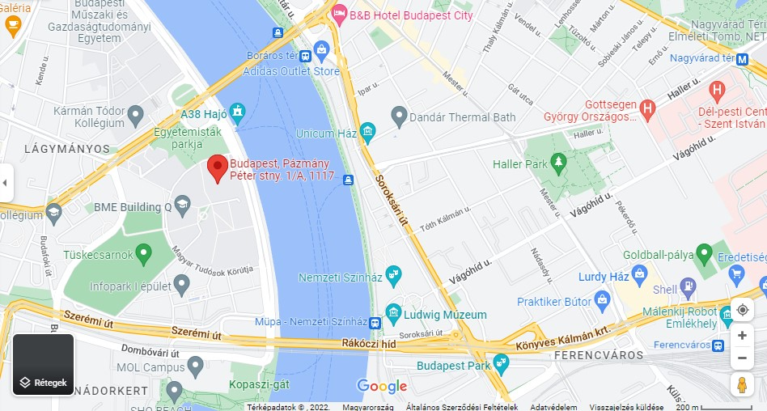

**PICTURE 3**: City map: <https://goo.gl/maps/emkTgT6xM5phckPi8>

## Restrooms

Restrooms, including accessible bathrooms, are located close to the elevators and stairs.

## Floor Map – 0. Level (Northern Building (Északi Tömb)

Floor Map – 0. Level (Norther Building (Északi Tömb) 

PICTURE: Floor Map – 0. Level (Norther Building (Északi Tömb) More information: https://zaynze.deminasi.com/ 


**PICTURE 4:** Floor Map – 0. Level (Northern Building) (Északi Tömb) More information: <https://zaynze.deminasi.com/>

# TRAVEL IN BUDAPEST

## Travelling to and from the Petőfi Bridge by Tram 4 or 6 or buses

**PICTURE 6**: Pázmány Péter sétány 1/A. Budapest, Hungary H-1117 Map <https://goo.gl/maps/emkTgT6xM5phckPi8>

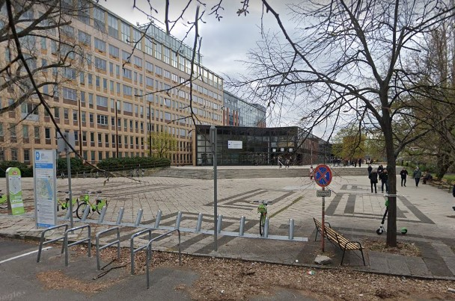

**PICTURE 7:** Entrance (inside with a globe) walking from the **Petőfi Híd Budai hídfő** Pázmány Péter sétány 1/A. Budapest, Hungary H-1117

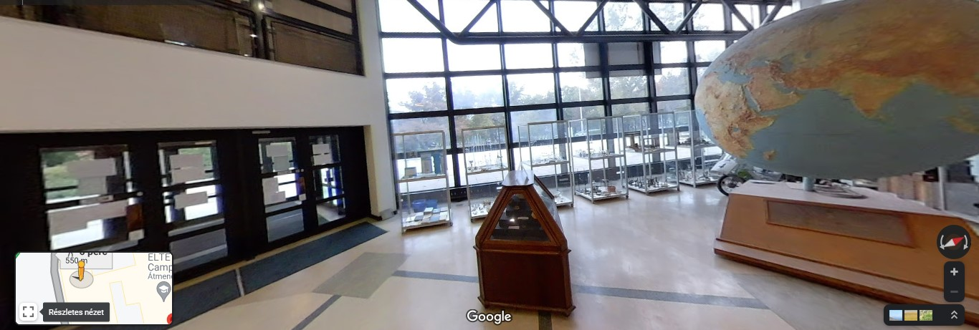

## Travelling with public transport

* Budapest public transport: <https://bkk.hu/en/timetables-trip-planner/>
* Budapest Travel planner (available in English): <https://go.bkk.hu/>

**PICTURE 8:** Budapest Go Travel Planner <https://go.bkk.hu/>

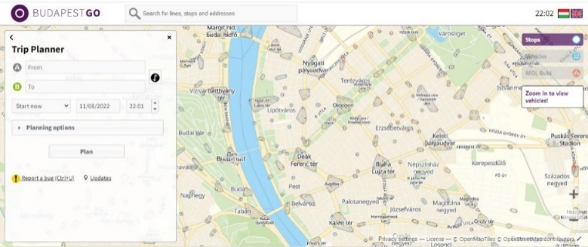

* Budapest Travel planner (available in 4 languages, including in English) **Budapest Menetrend Application** to your smartphone: <https://tinyurl.com/48c4esww>

**PICTURE 9**: Menetrend App Logo – Company: AppCorner Kft.<https://tinyurl.com/48c4esww>

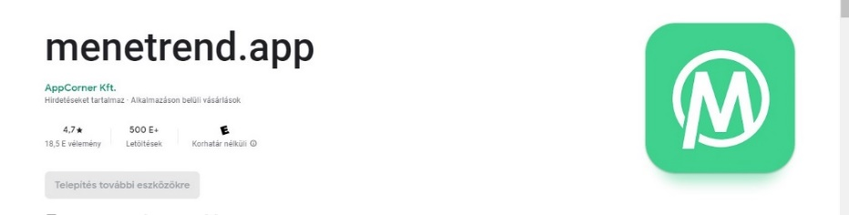

## Accessible transport

* <https://bkk.hu/en/travel-information/public-transport/accessibility/>

## MOL BUBI Facilities

What is MOL Bubi? MOL Bubi is a public transport service by BKK, which offers a quick and eco-friendly travel option in urban transport with 24/7 availability. (Visit the website: <https://molbubi.hu/en/>) MOL Bubi was created in 2014 to provide a fast, efficient and sustainable mobility alternative in Budapest. The service transformed in 2021 based on user feedback and experiences, which resulted in the total remodelling of the bicycle, the infrastructure and pricing. MOL Bubi has become an integral part of city transport in the past few years, and it can also be easily combined with other modes of public transportation.

MOL BUBI 


**PICTURE 10**: MOL Bubi

## Travelling by taxi and facilities

* Please, make sure that you travel with Budapest Licensed Taxis. Payment is available by cash or card.
* <https://bkk.hu/en/travel-information/cars-and-freight-transport/taxi-services/>
* **Travelling with a baby in the taxi:** Requesting a baby seat to the car is available in a **6x6 Taxi** – age and weight information are needed for the taxi company to provide the appropriate baby seat. <https://www.6x6taxi.hu/szolgaltatasaink/>

**PICTURE 11:** Licensed Budapest Taxis



# Hungary and Budapest Information

* Learn more about Hungary: <https://visithungary.com/>
* Learn more about Budapest: <https://www.budapestinfo.hu/en/>
* Reviews and updates about Budapest: <https://welovebudapest.com/en>
* Spas: <https://www.spasbudapest.com/>
* Restaurants: <https://welovebudapest.com/en/gastro>
* Restaurants with accessible bathrooms:

<https://www.kiosk-budapest.hu/>

<https://varosligetcafe.hu/>

<https://vigvarju.vakvarju.com/>

<https://highnoteskybar.hu/>

<https://froccsterasz.hu/>

* Sugar-free cakes in Budapest

<https://welovebudapest.com/en/toplist/5-confectioneries-selling-tasty-sugar-free-cakes-in-budapest>

* Budapest’s best vegan and vegetarian restaurants

<https://welovebudapest.com/en/toplist/budapest-s-best-vegan-restaurants>

<https://welovebudapest.com/en/toplist/vegetarian-budapest>

## Weather Information Budapest Hungary

* <https://www.met.hu/en/idojaras/>

## Budapest Districts

# 

**PICTURE 12:** Budapest Districts Map <https://www.budapestbylocals.com/budapest-districts/>

Budapest Districts Map

## Hungarian Currency: Hungarian Forint (HUF)

* <https://www.mnb.hu/en/arfolyamok>
* <https://www.ecb.europa.eu/stats/policy_and_exchange_rates/euro_reference_exchange_rates/html/eurofxref-graph-huf.en.html>

## In case of emergencies, Emergency Care

* <http://www.studyinhungary.hu/living-in-hungary/menu/emergency-numbers.html>
* <https://www.budapestinfo.hu/emergency-care>
* <https://welovebudapest.com/en/article/2014/7/30/how-to-get-medical-care-in-budapest-emergencies-doctors-hospitals-and-more>
* EENA, the European Emergency Number Association, is a non-governmental organisation. Its mission is to contribute to improving people’s safety & security. <https://eena.org/>

General emergency service phone number 112

Police 107

Ambulance 104

Fire service 105

24-hour English language crime hotline +36 1 438 8080

English language telephone directory service 191

International operator 199

# ONLINE PARTICIPATION

## Access and participation in the online environment

Thank you for registering and participating in the hybrid conference. Here, we would like to share some information about the online facilities.

## Access the online platform

1. **Conference Link:** You can join via the online conference link (the link(s)) will be directly sent to your e-mail address.
2. **Access Zoom:** It is not necessary to pre-install the Zoom program on your computer if you want to participate in a meeting because clicking on the link in the invitation should work, and the download will start automatically the first time you use it. Once the installation is complete, the Zoom login window will appear where you can choose to join a meeting (Join a Meeting)
3. **Installing (in case):** You can install the Zoom program on your computer in advance, so you no longer have to wait for the program to be installed when you are invited to the first meeting. You can download the Zoom program from the following locations: [https://zoom.us/support/download](https://zoom.us/support/download%20) or <https://zoom.us/client/latest/ZoomInstaller.exe>

## Step by steps on how to join the online platform

1. **Link to join**: Click on the meeting link in the e-mail! You will receive two access codes: a link and an ID (Meeting ID).
2. **Join a Meeting button /Launch the Meeting**: Please, enter the meeting ID (MEETING ID) and the meeting password (PASSCODE)!
3. **Your name**: If the program asks for your name, please enter your preferred name.
4. **Waiting room/Lobby:** After logging in, you may have to wait until the following text is displayed: “Please wait until the organiser (host) starts the conversation.”
5. **Join Audio Conference by Computer:** Please use the *“Join audio conference by Computer”* button If the organiser has started the meeting.

## Zoom Platform Icons

During a discussion, you can find the microphone, video, and chat window interfaces in the lower left part of the screen (by moving the mouse). Below, we share the functions and **keyboard keys** to access the various icons.



1. **Sound/Microphone:** Click on the microphone icon on and off. A red cross indicates that you are switched off, which means no one can hear you.
2. **Chat button: You can send a message to the participants by clicking the. The panel appears on the right**.

1. **Camera:** To turn the video button on and off, click this sign. A red cross indicates that your camera is off, in which case no one can see it. In meeting controls, click on the video to be visible/invisible to other participants.
2. **Indication for speaking:** In meeting controls: At Reactions, a hand appears in the lower bar, and there is a sign of raising hands which you can use to indicate that you want to speak.
3. **Break-out rooms:** CHARM-EU colleagues will assign you to be placed within different Break-out Rooms. Connection to space/room is automatically redirected to parallel sections JOIN ROOM. We will automatically redirect you to the joint space from the parallel sections, but the LEAVE ROOM button can also be used.

## Keyboard shortcuts for Zoom

We have selected the most valuable shortcuts ordered by the operating system for easy finding. Just click your profile picture, then Settings, then Keyboard Shortcuts. If the defaults do not suit you, you can re-assign shortcuts in your Zoom desktop client for both PC and Mac.

## The best Zoom keyboard shortcuts for Windows

Space - Push to talk (temporarily unmute yourself while you are talking)

Alt+V: Start/Stop Video

Alt+A: Mute/unmute audio

Alt+M: Mute/unmute audio for everyone except the host (for the host only)

Alt+F: Enter or exit fullscreen

Alt+H: Display/hide In-Meeting Chat panel

Alt+U: Display/hide Participants panel

PageUp/PageDown: Scroll between Gallery View pages on the screen

Alt+F1: Switch to active speaker view in video meeting

Alt+F2: Switch to gallery video view in video meeting

Alt+Y: Raise/lower hand

Alt+Shift+T: Screenshot

Switch to Portrait/Landscape View: Alt+L

## The best Zoom keyboard shortcuts for macOS

Space - Push to talk (temporarily unmute yourself while you are talking)

Command(⌘)+Shift+A: Mute/unmute audio

Command(⌘)+Shift+V: Start/stop video

Command(⌘)+Shift+N: Switch camera

Command(⌘)+Shift+F: Enter or exit fullscreen

Command(⌘)+Control+M: Mute audio for everyone except the host (for the host only)

Command(⌘)+Control+U: Unmute audio for everyone except the host (for the host only)

Command(⌘)+Shift+W: Switch to active speaker view

Command(⌘)+Shift+W: Switch to Gallery View

Control+P: View the previous screen in Gallery View

Control+N: View the next screen in Gallery View

Command(⌘)+Shift+H: Show/hide In-Meeting Chat Panel

Command(⌘)+U: Display/hide Participants panel

Option+Y: Raise hand/lower hand

## The best Zoom keyboard shortcuts for iPadOS

The shortcuts for iPadOS are a little more limited; unfortunately, there is no push to talk with the space bar.

Command + Shift + A: Mute/unmute my audio

Command + Shift + V: Start/stop my video

Command + Shift + H: Display/hide chat

Command + Shift + M: Minimise meeting

Command + U: Display/hide manage participants

Command + W: Close the front window

# THANK YOU, EVALUATION & COMMENTS

## A thank you to various Support Personnel and Volunteers

Throughout the conference design, delivery, and monitoring, we are working with many wonderful colleagues and students who are providing their support to create an inclusive conference environment. We are grateful for all people who contribute with their dedication, time, and energy to make a successful event!



**PICTURE 13**: A Thank you Letter

## Conference Evaluation Form

We are committed to improving the quality of our events by implementing participants’ constructive feedback.

Access the evaluation form: <https://forms.office.com/r/3Cfpp9Y8uh>.

Contact us if you at [charmeuwp6@elte.hu](mailto:charmeuwp6@elte.hu) to require this form in any other format.

Deadline for the evaluation submission: **30st Sept 2022, 23:59 CEST**

## Comments on-location & online

We would be delighted to hear from you to improve your CHARM-EU experience regarding access and inclusion. You are welcome to contact Agnes Sarolta Fazekas, CHARM-EU Work Package 6 Inclusiveness Leader, via [fazekas.agnes.sarolta@barczi.elte.hu](mailto:fazekas.agnes.sarolta@barczi.elte.hu) & [charmeuwp6@elte.hu](mailto:charmeuwp6@elte.hu).

1. <https://www.britannica.com/biography/Alexander-Pope-English-author>